The Commonwealth of Massachusetts
Division of Professional Licensure
Public Warehousemen License
is hereby granted to
Pursuant to Massachusetts General Laws c. 105 § 1
AMA Warehouse and Distribution
14 Dunham Rd
Billerica MA 01821

Number: |  | 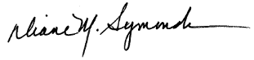  PW-000902 |  | Issue Date: March 24, 2020
Commissioner DIANE M. SYMONDS
This license shall not be transferred or assigned
Except upon the written permission of the Commissioner of the Division of Professional Licensure
1000 WASHINGTON STREET, SUITE 710, BOSTON MA 02118 (617) 727-3200 www.mass.gov/dpl

